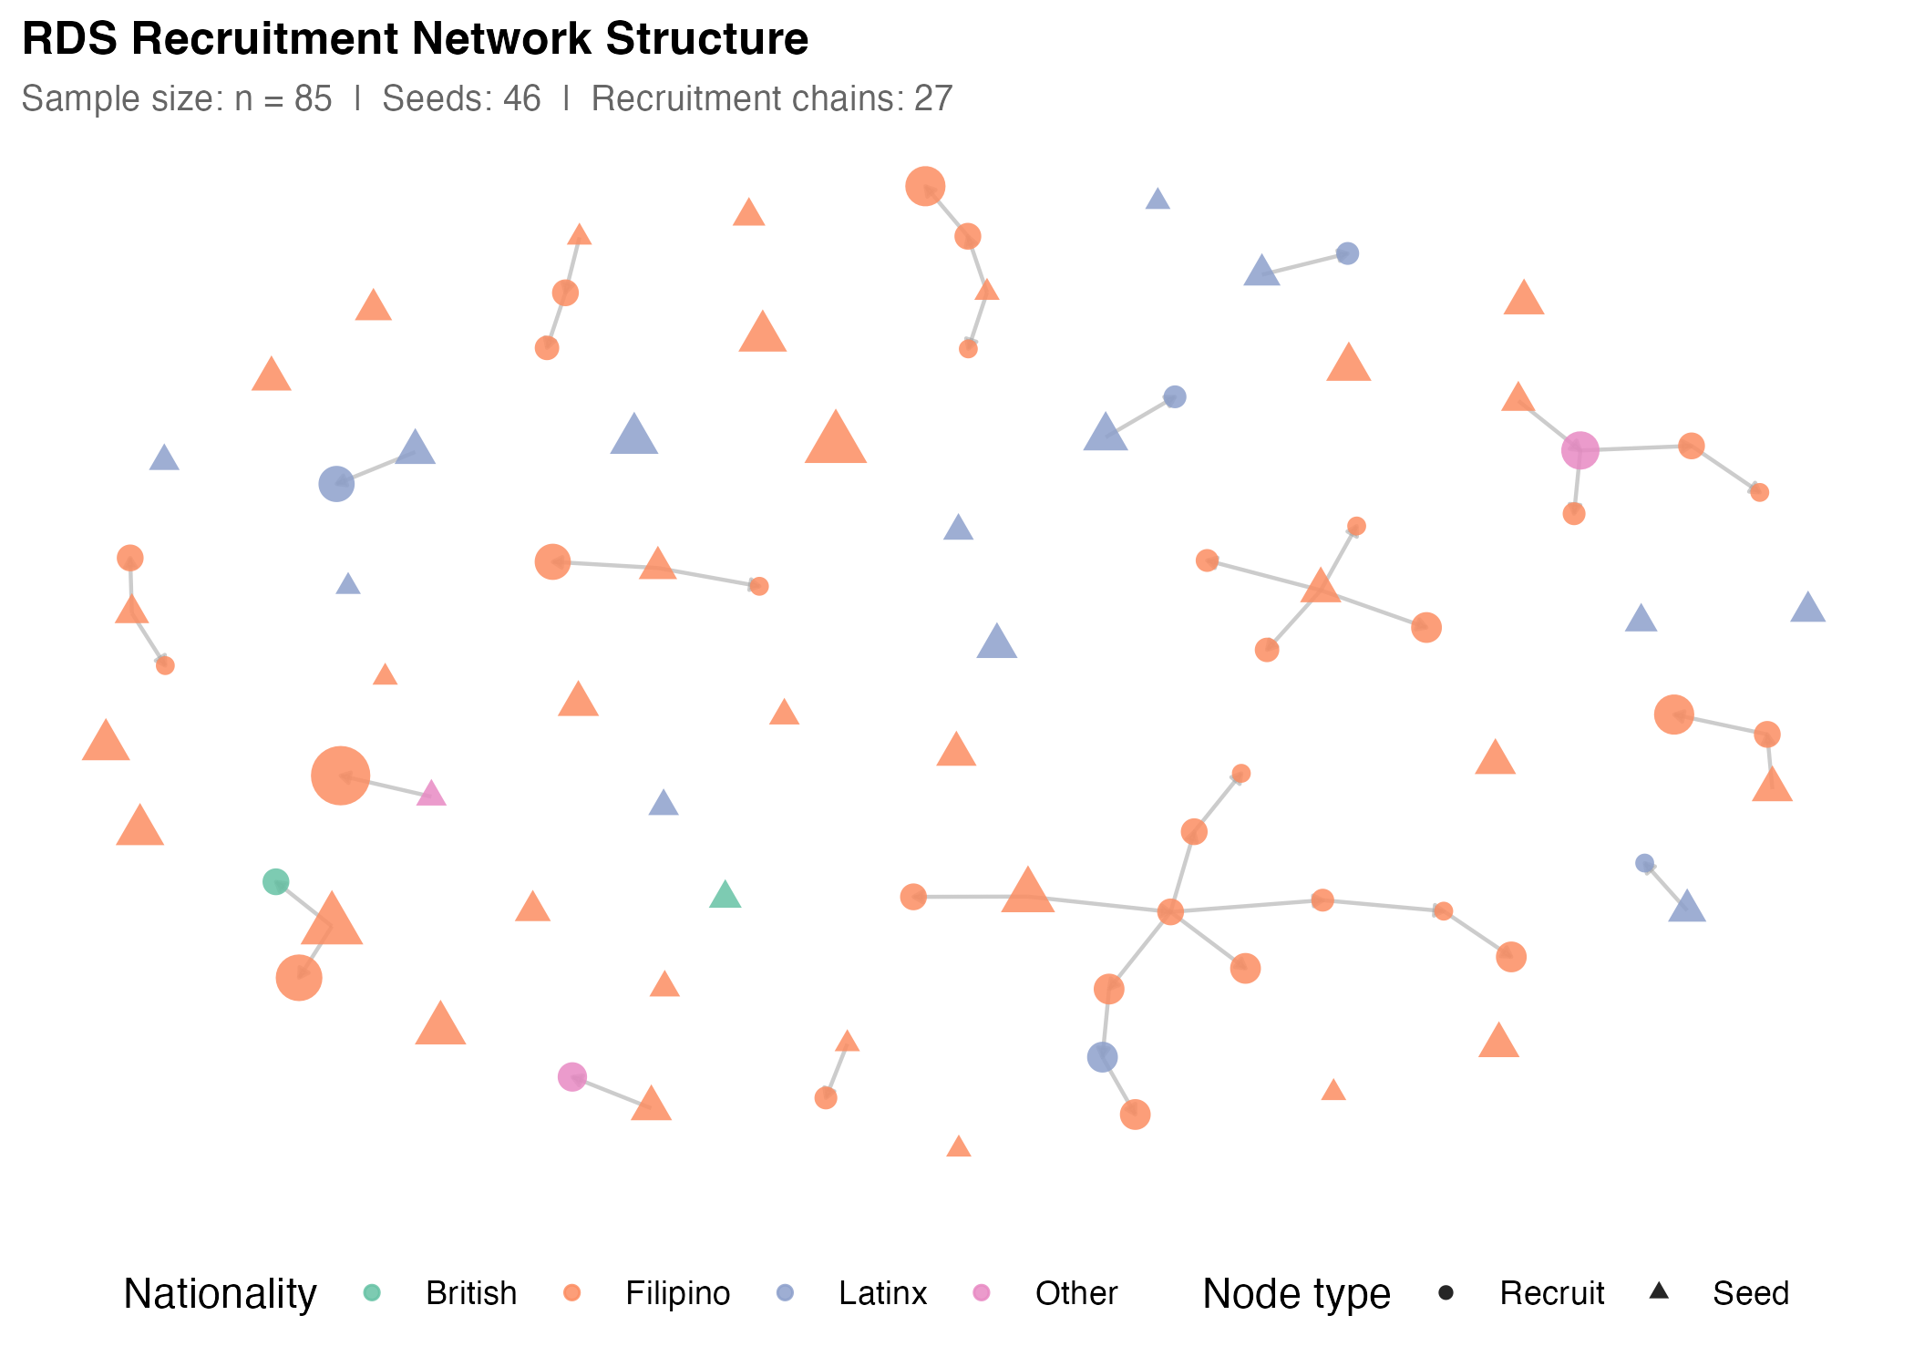
Figure 1. RDS Recruitment Network Structure. Recruitment chains showing seed nodes (triangles) and recruit nodes (circles). Node colours represent nationality clusters; node size is proportional to network degree. Lines show recruiter-recruit relationships. Source: Authors' own work.

